**Exam 3 Topics Review**

**Questions:**

1. Explain the logic of the two-way ANOVA.

Main effect of Factor A (rows)

Main effect of Factor B (columns)

Interaction: The joint effect of Factors A & B; think of as the leftover variance that isn’t accounted for with just the other two

* 1. What is the null and alternative hypothesis for a generic two-way ANOVA

Main Effects-

H0: All groups have equal means OR

H1: At least 1 group is different than the others

Interaction-

H0: There is no interaction between factors A and B – all the difference between means are explained by the main effects

H1: There is an interaction between factors A and B – the mean differences between factors A and B are not accounted for by the overall effects of the two factors

* 1. Why is the ANOVA method part of the family of statistics called the General Linear Model?

Because it calculates the model the same way as a linear model:

y=mx+b; you just add in your factors -> y=mx1 + mx2 + mx1x2 + b

* 1. If you remove one of the factors of the two-way ANOVA what will happen to the
     1. SSbetween term and why?

SSbetween = SSFactorA + SSFactorB + SSAxB

If you removed one of the factors (but keep the data) you lose that factor and the interaction variable, the unaccounted for variance goes into the SSwithin term – the variance goes back to unexplained variance

The residual error term and degrees of freedom increase

The F will drop because the error term increased and when you divide the result is substantially decreased

* + 1. MSerror term and Why?
  1. What is an interaction?
     1. How do interactions arise?
     2. How are they related to main effects?
  2. Explain the logic of the two-way ANOVA Source Table

Practice: https://people.richland.edu/james/ictcm/2004/anovagen.php

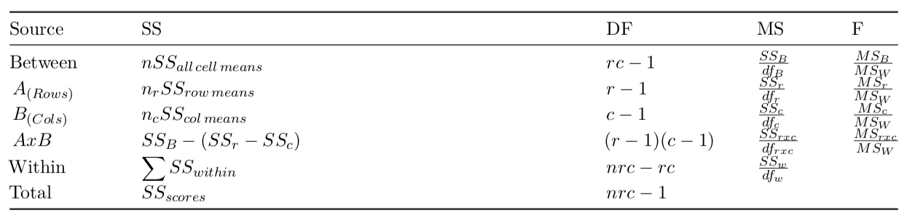

N = the number of all measurements/subjects

n = the total number of means

nr = the number of means in the rows

nc = the number of means in the columns

r = rows

c = columns

* + 1. Explain where each formula in the table comes from:
       1. What does each represent?

SSbetween = SSFactorA + SSFactorB + SSAxB

* + - 1. How do the cells in the table relate to each other?
  1. What are partial effect sizes and what are their benefits and weaknesses?

Look at the eta squared section for this – basically you use the individual error terms from the single factor instead of all factors because then it is more specific and translatable

* 1. What are simple effects?

A simple effect would be a test within a family – like a post hoc test of a main effect

* + 1. How do you do them?

Test the main effects that are significant

Contrasts, poly, consecutive (if the data are ordinal)

* + 1. When should you do them?

When there is a significant main effect that needs to be unpacked – you can choose the one that best fits the data (looking at the graphed means and whether or not the data are consecutive) then choose the analysis that has the least number of tests

* 1. When you have designs large design (2x3, 3x3, etc.):
     1. If you have a 3x3 design – How many simple effects should you do and why?
        1. Provide a visual
  2. What are the benefits and drawbacks of designing multi-factors studies?

**What you should be able to do:**

1. Calculate a two-way ANOVA
2. Be able to select and implement the proper follow up tests given your hypotheses.
3. Be able to unpack an interaction in complex studies.
4. Explain the results of the ANOVA and follow-up tests in APA format.
5. Explain what violating the assumptions of the ANOVA might mean for your results and how to correct for those violations.